Roll Number: 190070049

Name: Rathour Param Jitendrakumar

Course: Electronic Devices Lab

Course Code: EE236

Q1) a)

I_C vs V_CE

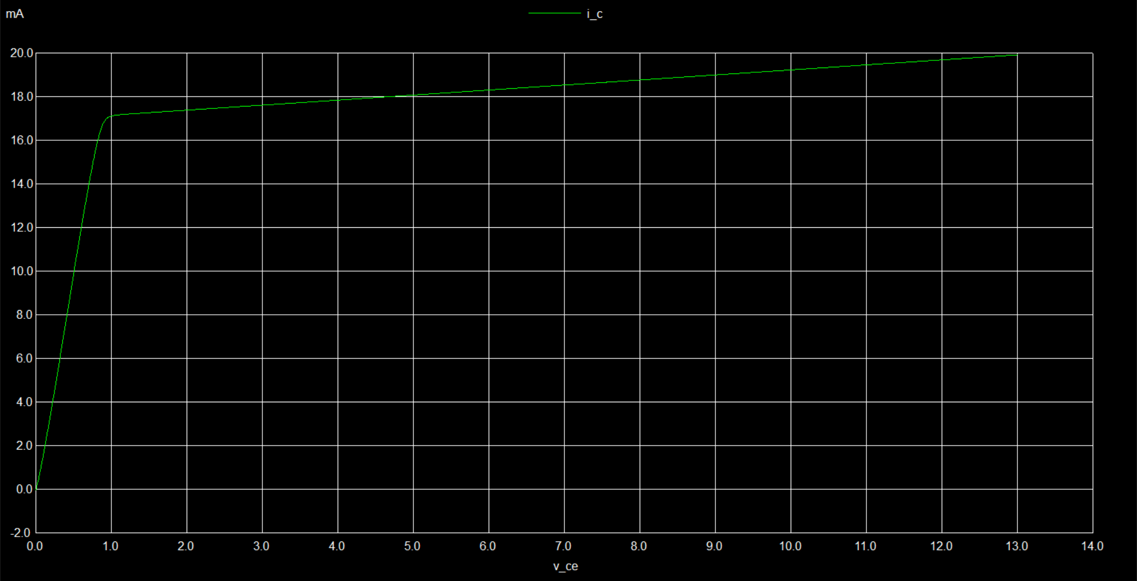

I_C vs temp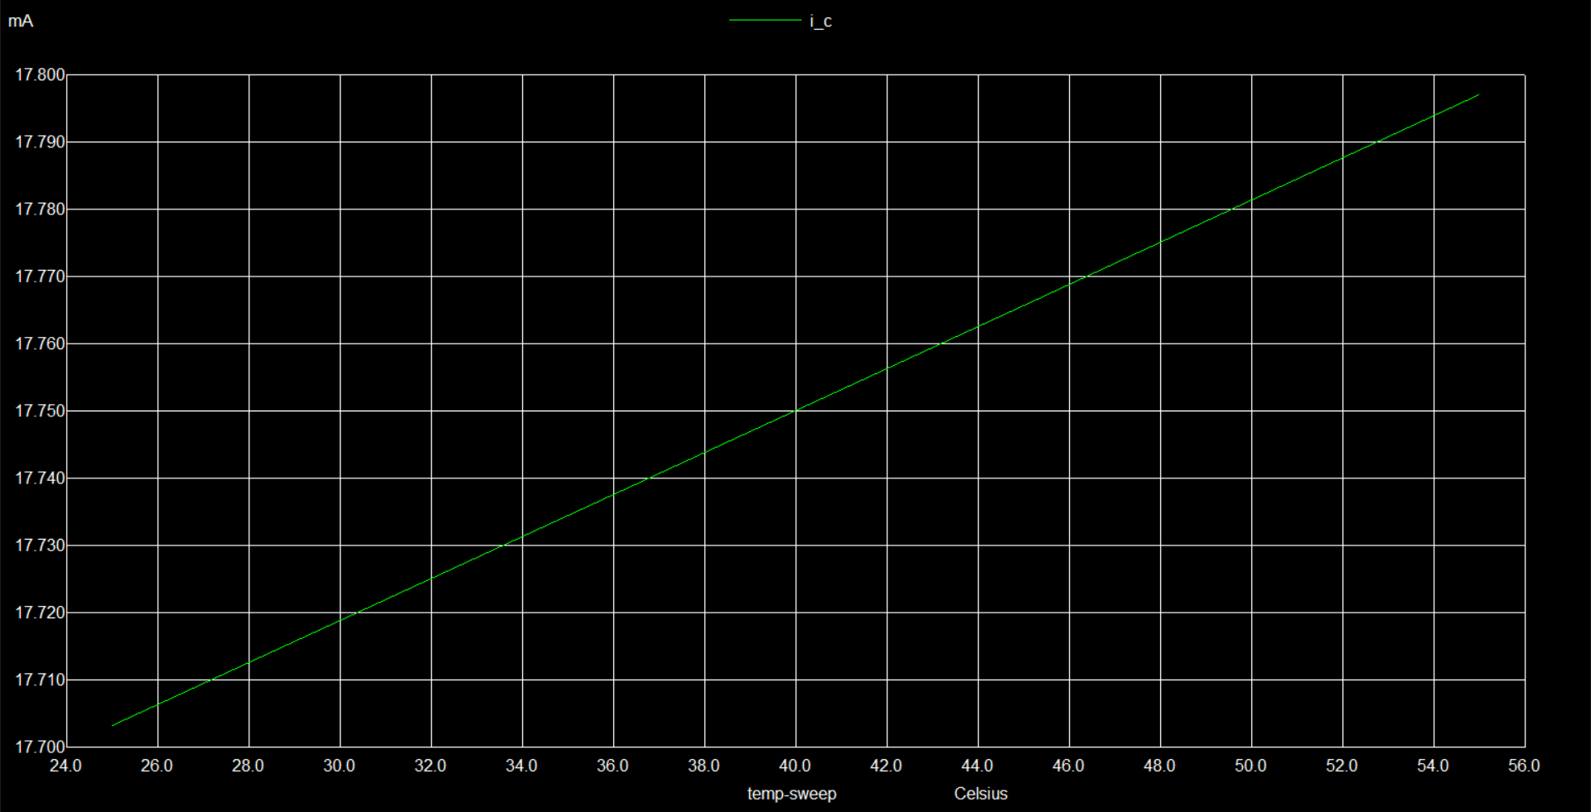

Q1) b)

I_D vs V_DS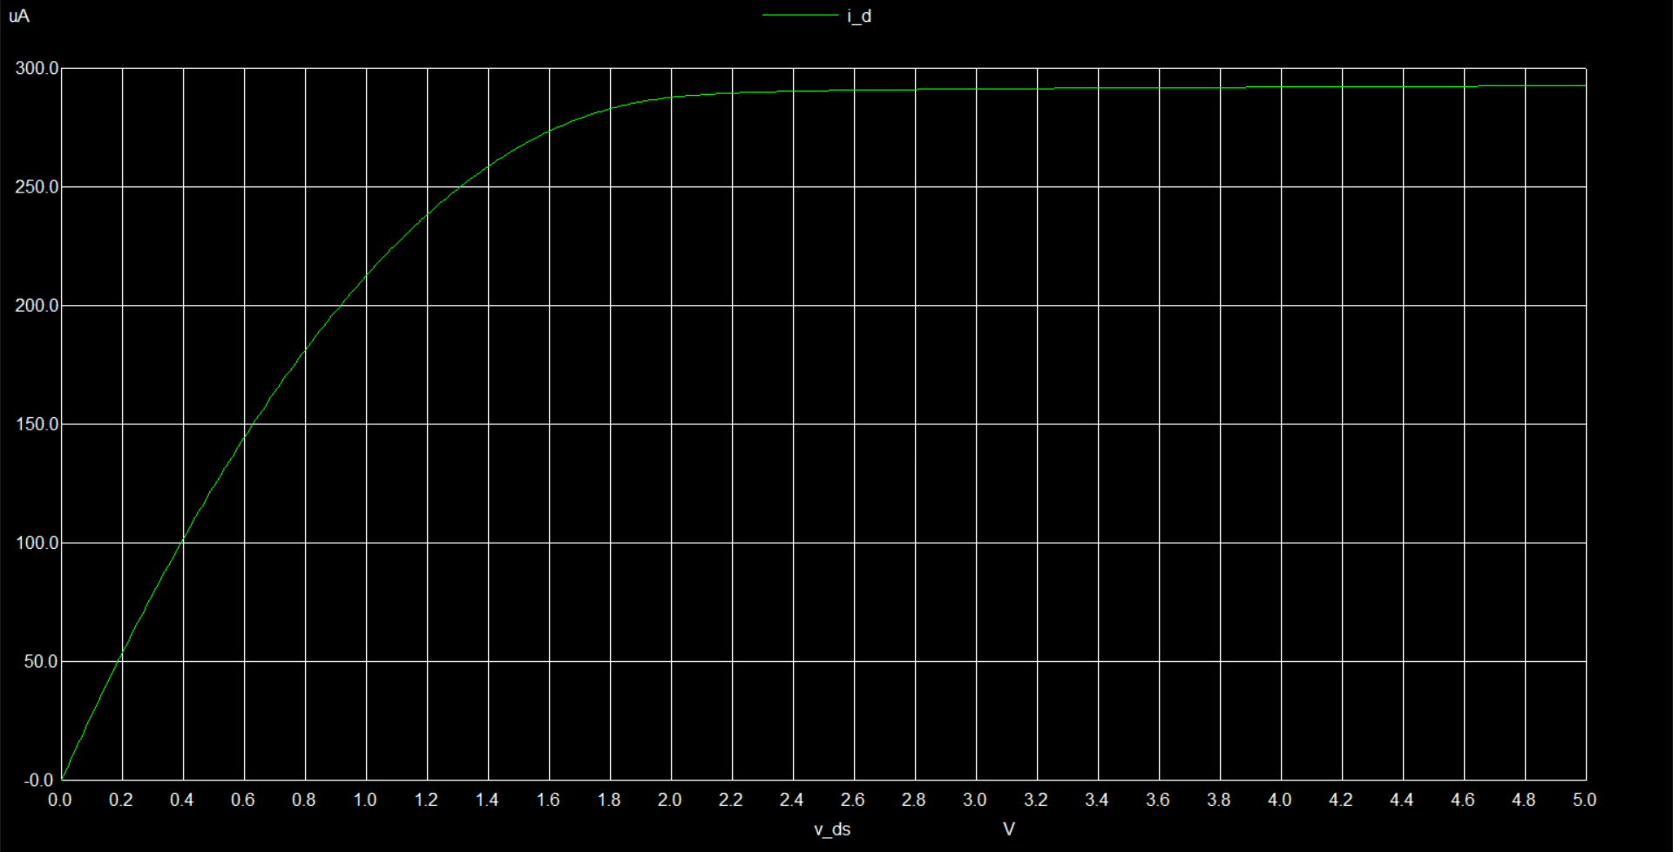

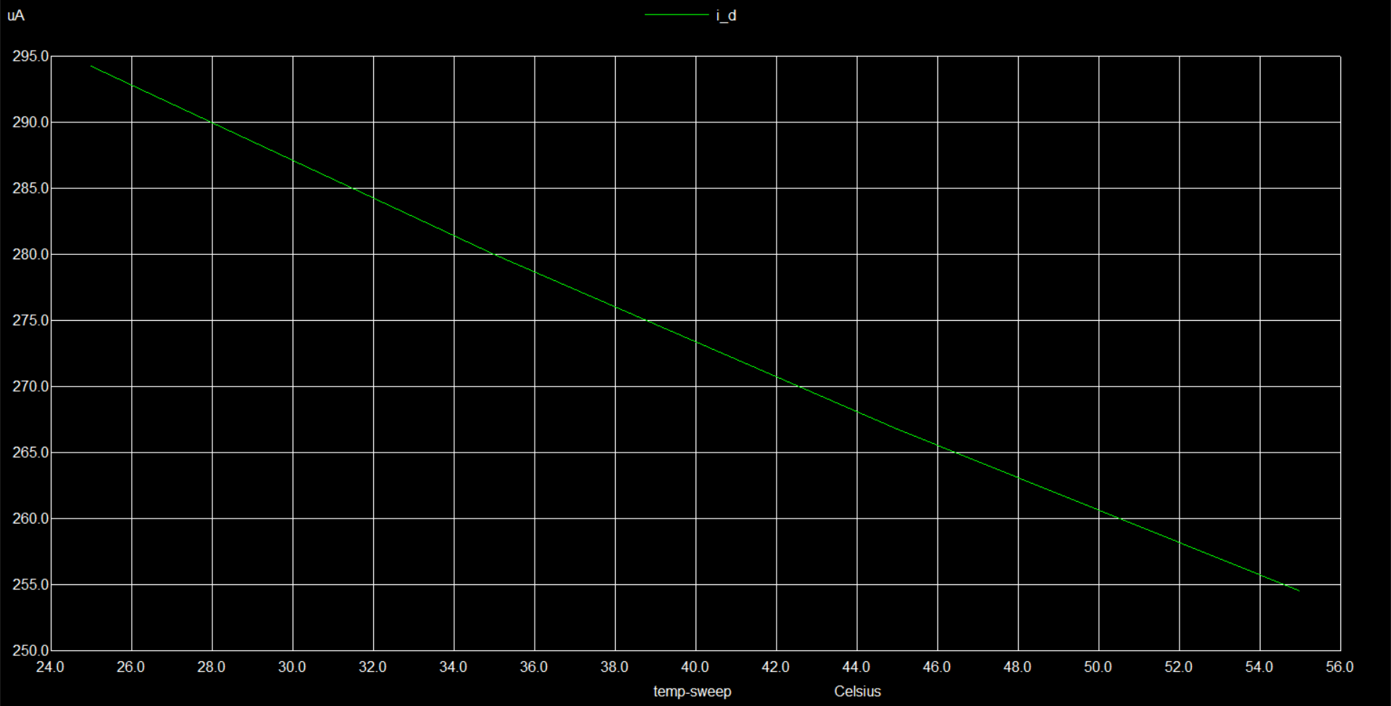I_D vs temp

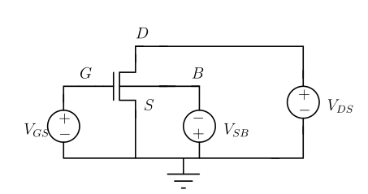

Q1) c)

V_out vs V_in

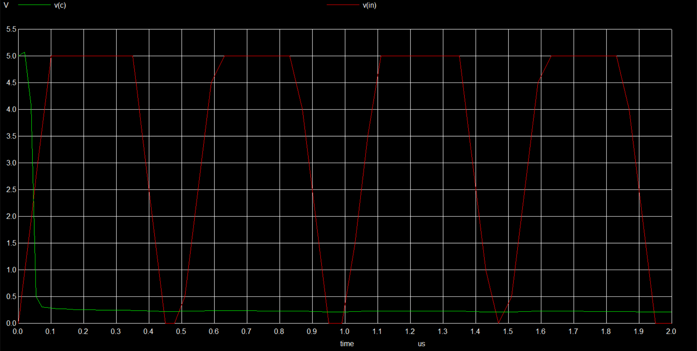BJT

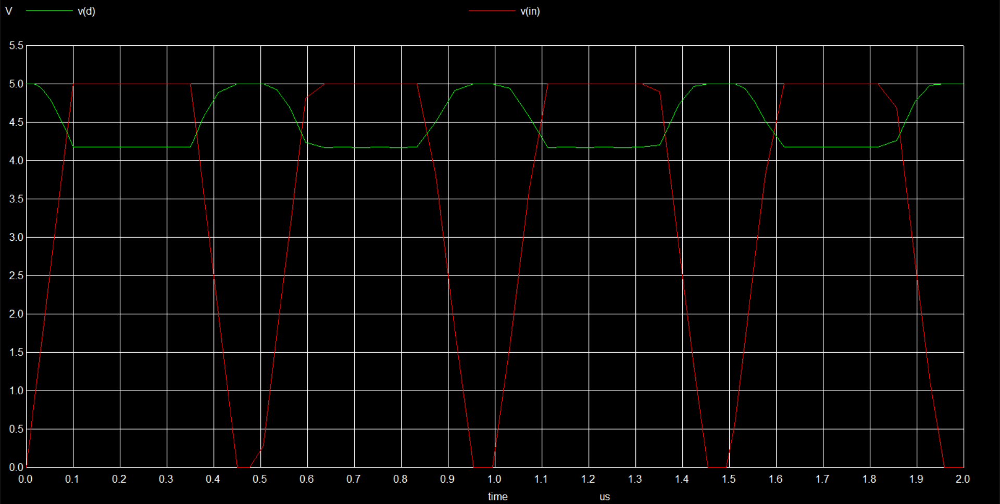NMOS

I_C vs I_B

BJT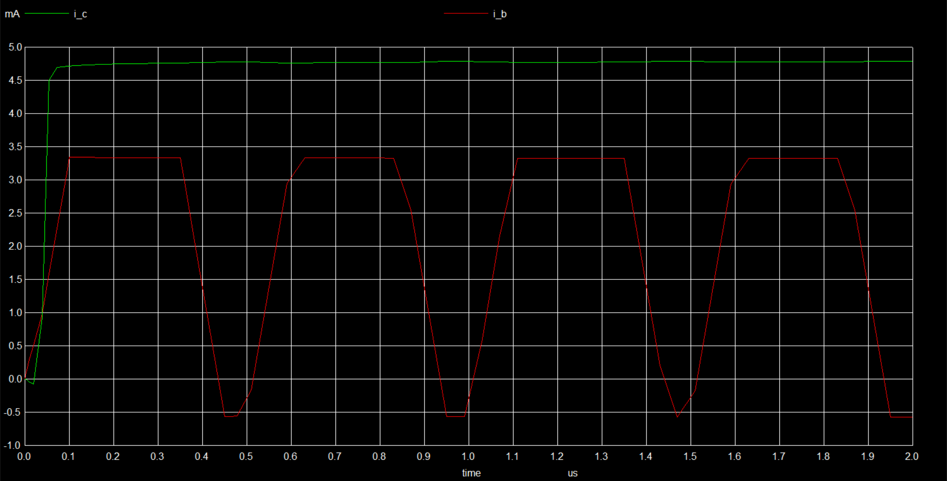

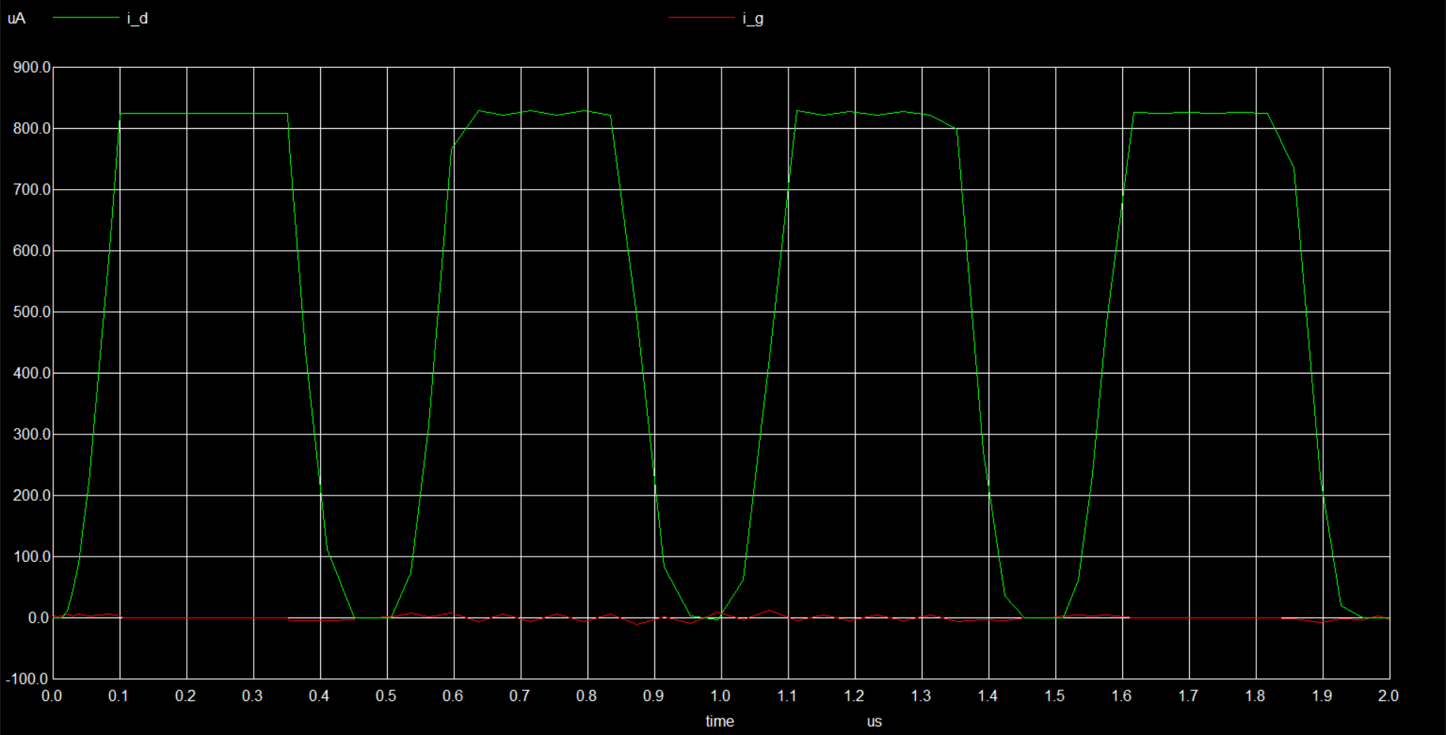NMOS

BJT doesn’t turn off

NMOS turn off time = 9.73821e-07 - 9.53659e-07 = 20.162ns

Q2) a)

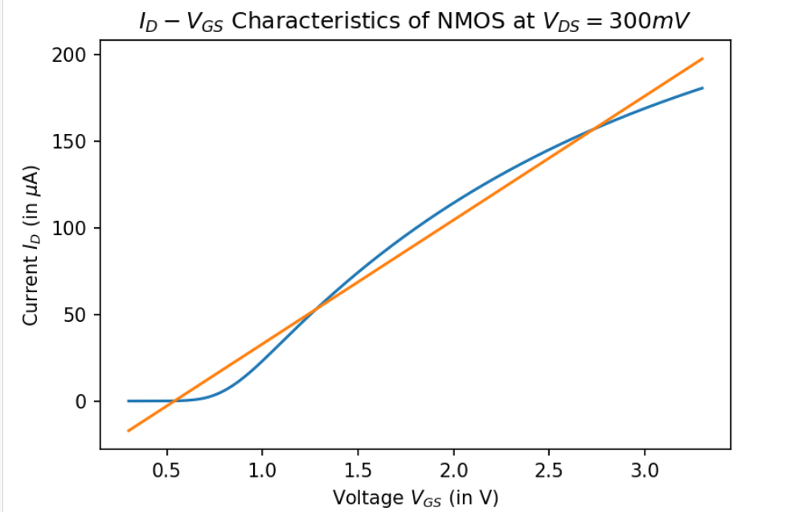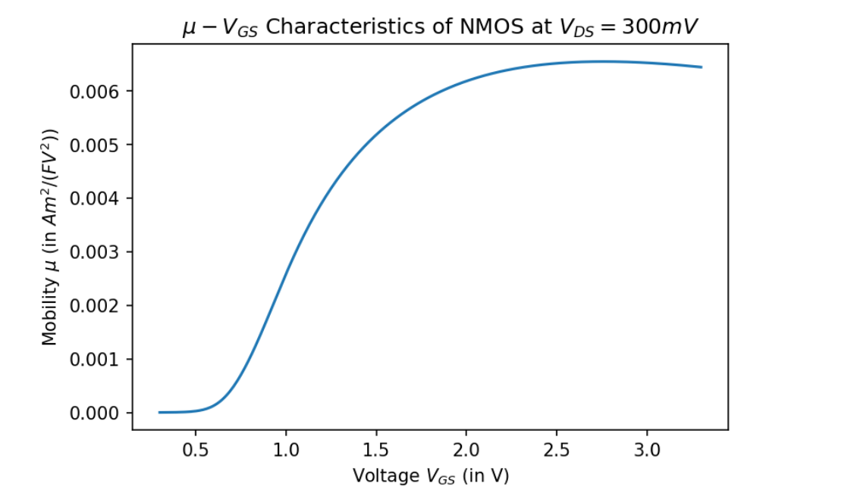Blue – Original Value

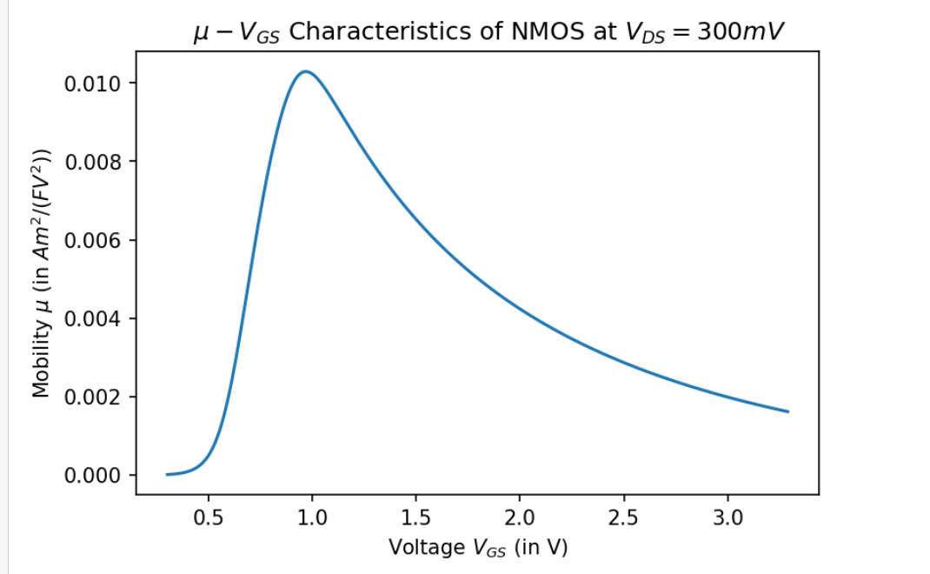

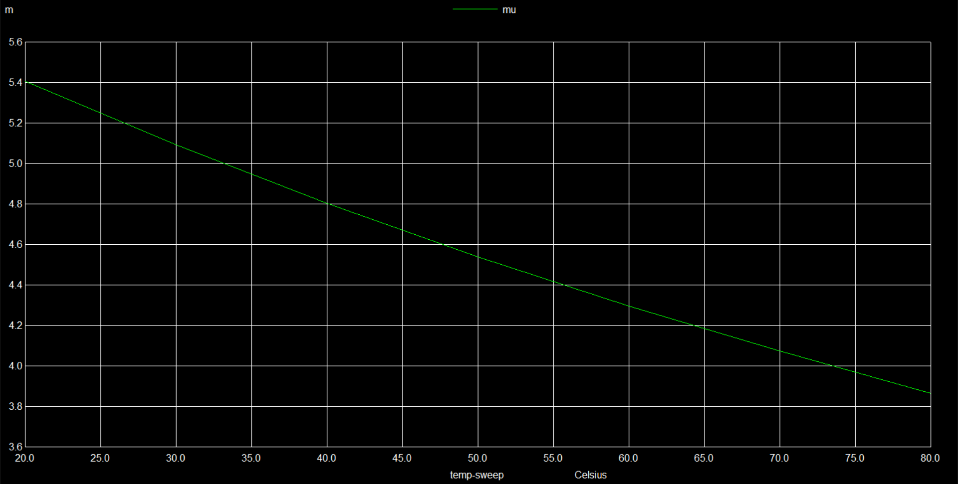Q2) b)

V_GS = 1.5V

Mobility vs temp

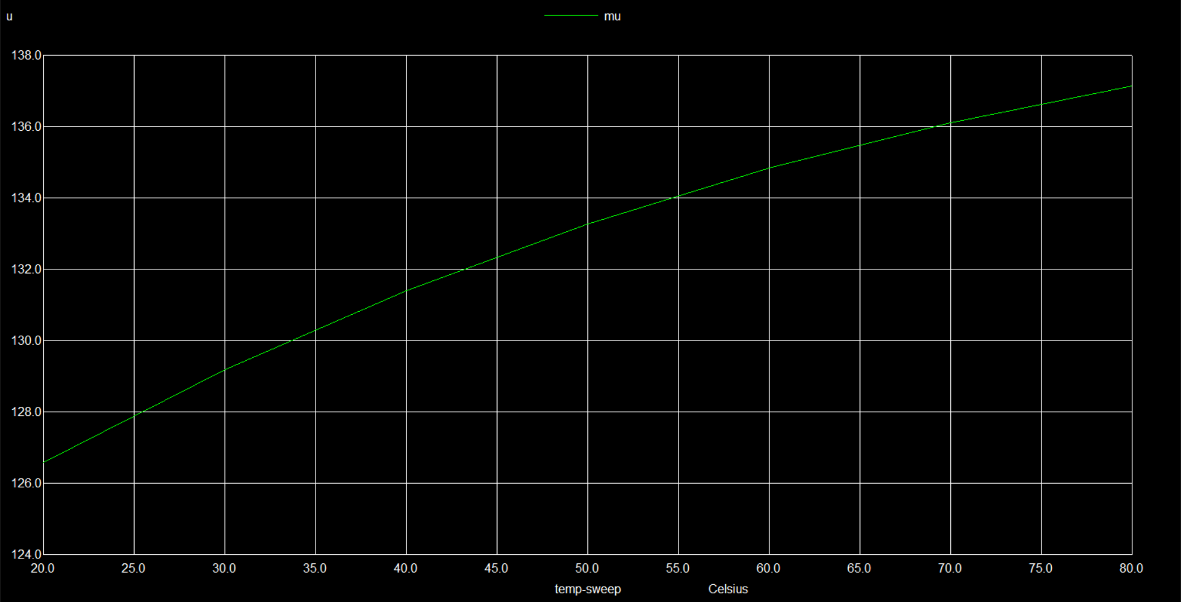V_GS = 0.6V

Q2) c) SS in mV/decade

41.326124249702865

48.70882175407157

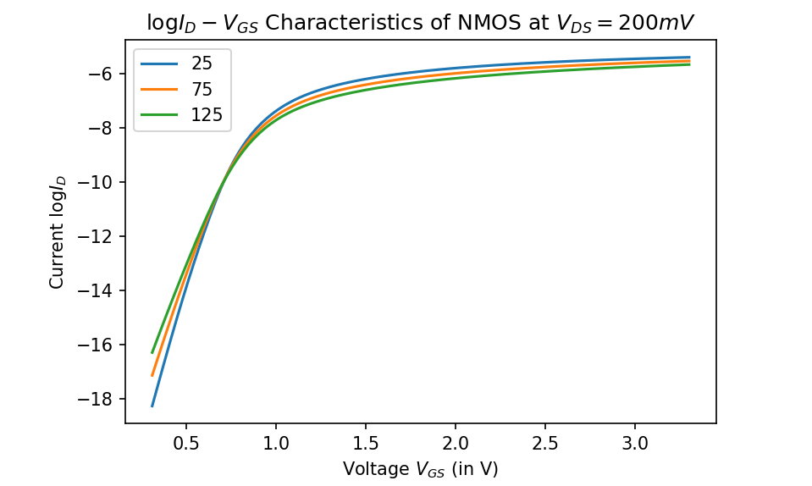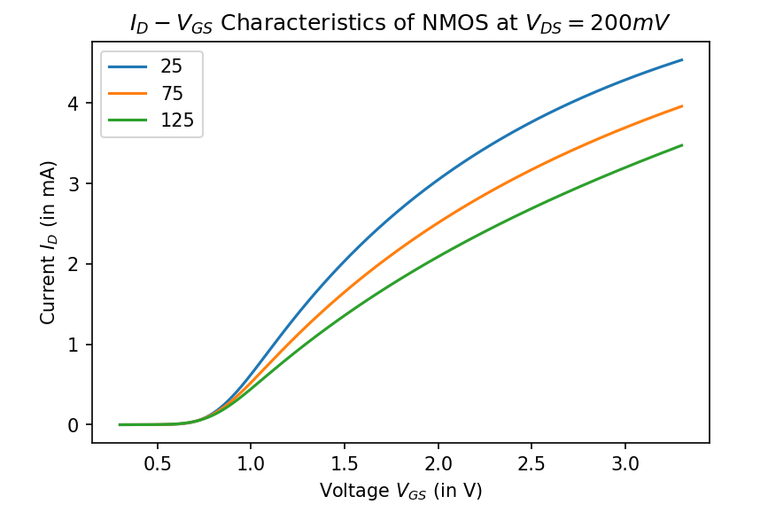56.56533984425148

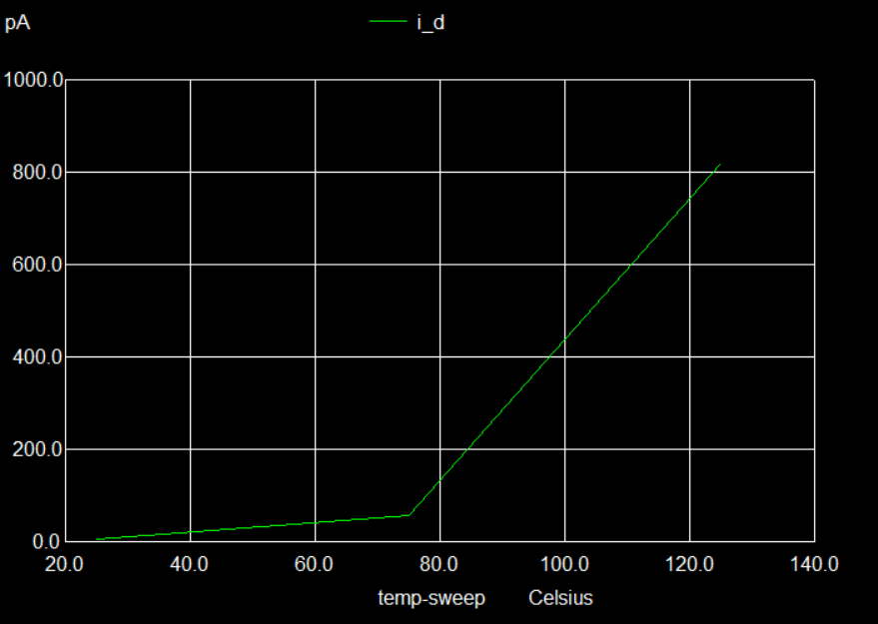Off current



Q3) a)

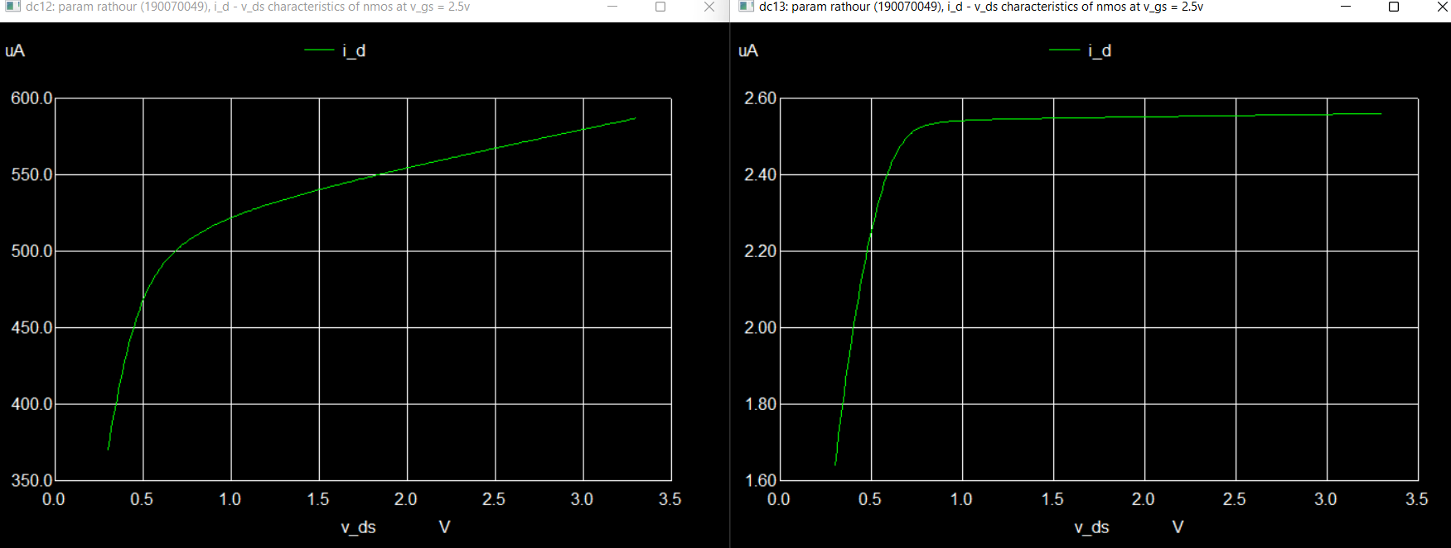R_o = 7122.99ohm and 1.10646Mohm resp

b)

41.326124249702865

48.70882175407157

SS in mV/decade  
